**A**

**PROJECT REPORT**

**ON**

**“ Placement Management System “**

Submitted to

**Savitribai Phule Pune University**

**Under Subject**

**PROJECT WORK (CA-605)**

**TYBBA(CA)**

By

**NAME: PITRE ANIKET AMOD**

T.Y.B.B.A(C.A) Roll No. - 60

Guided by:

**( Mrs. Suwarna Mulay )**

**Head of the Department**

Dr. Mrs. L. M. Bhat

B. Y. K. (Sinnar) College of Commerce, Nashik - 5

Year: 2021 – 2022

University Exam Seat No:

|  |  |
| --- | --- |
| Gokhale Education Society’s  **B.Y.K. College of Commerce**  **Prin. T. A. Kulkarni Vidyanagar, Nashik – 5.**   |  | | --- | | ‘NAAC’ Accredited with Grade ‘A’  ISO 9001-2015  Certified College |     Certificate    This is to certify that Mr. PITRE ANIKET AMOD of TYBBA (CA), Roll No.60 has undertaken and completed the Project Work as required by the rules of Savitribai Phule Pune University for the year 2021 - 2022.  He has completed his Project Work on the following topic:  **Placement Management System**      Date: 24/05/2022 Project Guide Principal  ( Mrs. Suwarna Mulay ) (Dr. Ram Kulkarni)        Date: 24/05/2022 Internal Examiner External Examiner |

ACKNOWLEDGEMENT

I have pleasure in successful completion of this work titled Placement Management System.

I wish to express my deep sense of gratitude to Savitribai Phule Pune University for giving me the opportunity for taking up the project work.

The special environment at B.Y.K. College of Commerce, Nashik that always supports educational activities, facilitated my work on this project.

I acknowledge the support, and encouragement, extended for this study by Principal Dr. Ram Kulkarni & HOD Dr. Mrs. L. M. Bhat. Our vocabulary is insufficient to explain their erudite & prudent ideas in handling an intricate subject such as this.

I am very much thankful to Mrs. Suwarna Mulay for her encouragement and guidance for this project work. It would not have been possible for me to complete this work without her suggestion on every part of this work.

I acknowledge the authors, whose works gave me insight and information related to this subject.

I am thankful to Library staff and Administrative staff of the BYK College who directly, or indirectly, have all been helpful in one way or another.

I thank my father and mother who encouraged me to extend my reach with their help and support, I have been able to complete this work.

Date: 24/05/2022 Signature

Name of the Student

(Aniket Amod Pitre)

**Declaration**

I hereby declare that this project titled “Placement Management System” submitted by me is Based on actual work carried out by me as per the project norms .I have collected the necessary data and information from the concerned relevant and genuine business professional and users .I have validated all the data and carried out future analysis, interpretation and other necessary processes needed to obtain result. I have cited the necessary sources and references in the project.

Date: 24/05/2022 Signature of the student

Place: Nashik Name of the student

(Aniket Amod Pitre)

Class:

Roll No: -60

Seat No:

CBCS: 2021-22 T.Y.B.B.A(C.A.) Semester V

Index

* 1. Abstract:-

* 1. Introduction:-

2.1 Problem Statement.

2.2 Purpose/Objectives and goals.

2.3 Project scope and limitations.

3. System Analysis:- 3.1 Existing system.

3.2 Project perspective, features.

3.3 Requirement Analysis – Functional Requirements, performance requirements, security requirements, etc.

4. System Design:-

4.1 System Model: Usecase Diagram and Class Diagram.

4.2 Data Model.

4.3 User Interface.

5. Implementation Details:-

* 1. Software/Hardware Specifications.

6. Outputs and Reports:-

7. Testing:-

* 1. Data Validation.

8. Conclusion:-

1. Future Scope:-

1. Bibliography and Refrences :-

1. Abstract :-

From a student’s perspective, placements can bring a wide range of benefits and opportunities. Training and management of placement is a crucial part of an educational institution in which most of the work is done manually. Manual system in the colleges requires a lot of manpower and time. With this project we aim to develop a web portal to solve this issue. The project is aimed at developing an application for the placement department of the college. The system is an application which will be accessed and effectively used throughout the organization with proper login enabled. It can also be used as an application for the Placement Officers in the college to manage the student information about placement thus reducing the manual work and consumes less paperwork. The system also provides the facility of viewing the personal and academic information of the student. The system gets the requested list of candidates for the companies who would like to recruit the people according to their eligibility criteria. This framework is used to facilitate the process of making the program.

2. Introduction:-

Manual Training and Placement which is done at various colleges is by human intervention due to which there is a maximum chance of errors. The major problem is searching and updating of the student data. Placement officers have to manage the student’s profile and their documents. Placement Officer has to collect the information of various companies who comes for recruitment.

Placement officers submit the information of students and if any changes or updates are required in the profile of any student, it has to be done manually. This process is so difficult and tedious when the number of users increases. This is tedious and time consuming. Chances of missing data are also possible. It is also difficult for collecting, managing, and updating student data as the number of students increases.

’Placement Management System’ like many other placement management web sites, provides information on placement providers and the placements and also keeps up to date information of all students. It is a platform where students can view and assess their opportunities. The system will be having different types of accounts for different types of users such as Admin, Student, and Company. A profile for each student is created with the necessary credentials for the portal. The system uses MySQL for database management and will sort the data of the student based on eligibility criteria demanded by the respective companies and a list of eligible candidates will be prepared and they can choose if they are interested to attend that particular drive or test. Based on this a final data-set is created and the interested candidates will be registered automatically by the system. This way it reduces the work of college staff or faculty from the problems caused by human error and wastage of time doing all processes manually.

The project involved designing a database along with its frontend and backend components to facilitate placements in the institute. The placement database management project has been made to give various access for different type of users i.e. students, administrator or placement officer and companies. Every user has his own limited set of features. The project involves use of various web and database technologies namely HTML, CSS, PHP, MySQL, etc.

2.1 Problem Statement :-

The existing system is doing all the processes manually. The Placement Officer should refer all the records kept for years ago to simply no details. This is tedious and time consuming. This process is so difficult when the number of users increases. There are a lot of limitations for the existing system. In manual Training and Placement all the work that is done by human intervention due to which there is a maximum chance of errors. The interface of student and a TPO is maximum which makes the system time consuming. At the records are stored in modified access sheets hence sorting is a problem.

* Existing system is totally manual process because of this it is slower.
* During analysis data is collected on the various files.
* Too much paper work and hard to maintain all the document sheets.
* Increases work of training and placement officer.
* Limited storage because information is stored in hard drive.
* Time consuming process because placement officer need to contact each and every student manually.
* Less security because of paper work.

2.2 Objective and Goal :-

The main objective of the placement management system is to reduce manual work and time. It is difficult and time-consuming to collect all the details from each student. To avoid this problem we have planned to develop a web-based placement management system.

* Easy to find out the list of eligible students attending the drives.
* It manages the details of student records, placement training, different placements happening in and out of the college.
* Saves the time of placement officer and faculties.
* Reduces the manual works.
* This system makes student information more secure.
* It is uses an android application for automation so it helps in fast access procedure in placement related activities.
* The facility of maintaining the details of the students.
* Reduces load of training and placement officer.
* Large storage because of information is store on the cloud.
* Every placement related notification and updates are available on android application so it reduces time.
* Time saving.
* Easily finding out the list of eligible students for company training and placement.

Purpose:-

Placement Management System manages student information in the college with regard to placement. It improves existing system .It has the facility of maintaining the details of the student, thereby reducing the manual work. It will save time and energy which are spending in making reports and collecting data. Placement Management System can be accessed throughout the college with proper login provided.

2.3 Project Scope and Limitations :-

The project has a wide scope. This project mainly helps in improving productivity and makes use of utilization of resources. There is no duplication of work as this was not the case when done manually. Thus it reduces labor and increases morale. The system intends user friendly operations which may resolve ambiguity. The project is a total management and informative system, which provides the up- to-date information of all the students in the college.

This system also help the college to overcome the difficulty in keeping records of hundreds of students and searching for a student eligible for recruitment criteria from the whole thing. It helps in effective and timely utilization of resources. The project facilitates user friendly, reliable and fast management system. The placement officer itself can carry out operations in a smooth and effective manner. They need not concentrate on record keeping. The college can maintain computerized records thus reducing paper work, time and money.

Limitations –

* Unavailability of University database lead to reduction of features.
* More secure and consistent student login can be ensured by making student s_id as referential attribute to university database student table.
* More company requirements can be added by using university database.
* The website is presented in a local server which limits its accessibility.
* Multiple Round interview are not allowed.

3. System Analysis :-

To design and implement a web-based placement management system. High-quality placements bring good benefits and positive impacts on students as well as for the colleges. During this process college finds it difficult and time-consuming to collect data from each student. In most cases they collect data manually. Working in a manual system in the colleges requires a lot of manpower and time. The placement management system is an online application that can be accessed throughout the college and outside with proper login details. This system can be used as an application for the placement officer, faculty coordinator of the college to manage the student information with regards to placement. The student is able to upload their information.

The web application is developed in framework The system will be having different types of accounts for different types of users such a profile for each student is created with the necessary credentials for the portal. The system uses MySQL for database management and will sort the data of the student based on eligibility criteria demanded by the respective companies. Also a link will be broadcasted to all eligible candidates via an email for them to choose if they are interested to attend the particular drive or test. The main feature of the system is a machine learning application that can predict placement probabilities of a particular student in different companies based on the previous placement frequency of his/her department, his skill set, marks, and other data available.

3.1 Existing System :-

In colleges the records were stored in excel sheets hence sorting the data is always a problem. The excel sheets are also less advanced. Hence sorting and searching problems arises. Updating Records is another tedious task. Due to the above problems the updating was very difficult and ambiguous. Data redundancy also occurs due to the duplication of files and records. The files were not stored in a hierarchical format, hence searching the eligible students was the greatest problem. The placement officer has to find out the eligible students by looking at the excel sheet. He/she has to see the marks of every student and their eligibility.

Another problem students face is that they are not made aware of the Training and Placement activity held in their institutions, hence there might have been a loss of opportunities. There is also a large communication gap between students and the placement officers as it is difficult to maintain coordination between them. The existing system is also inefficient as it could not take acknowledgment from the students attending a particular drive. Hence lots of confusion at the last moment also arises. As all this is done manually, there is a lot of workload on the placement officer.

The existing method used for placement management is not computerized . All the records are maintained manually. The departments or the management carry out this job manually making it more complicated and tedious most of the time. The best solution here is to computerize the current environment.

3.2 Project Perspective :-

This project is aimed at developing an web application for the Placement Department of the Colleges. In various colleges, training and placement officers have to manage the students’ profiles and the documents of students for their training and placement manually. Also Placement Officers have to collect the information of various companies who want to recruit students and notify students time to time about the placements.

Placement Officer also have to arrange profiles of students according to various streams and notify them according to company requirements. If any modifications or updates are required in the profile of the students or the Company, it has to be searched and done manually.

Hence the Placement Management System would maintain a huge database for the complete details of the students as well as the Companies in the Placement process which would help to save time and effort.

3.3 Featuers Of Placement Management System –

* The Placement Management System is to be developed as an attempt to take a record of Companies and students by restricting a large database that would be used for each.
* The System would provide the facility of viewing both the personal and academic information of the students and also the company.
* The System would also be able to search for eligible students and company with respect to their specifications and requirements.
* The eligible students would receive an email including the details of the Company, placement procedure and other details.
* Student Sign-up and Log-in.
* Company Log-in.
* Company sign-up, registration done by database administrator (Placement Officer).
* History containing yearly company statistics (Average Package, No of Students Selected).
* Everyone can see the Placement History.
* A Student can register in companies visiting his institute in his passing year and in which he/she is eligible to.
* A Student can deregister from company before commencement of the interview.
* Student can change his details (Phone no, passing year, CGPA).
* Repeating Students (can change their passing year) previous placement related data are deleted.
* Students can view available offers. Can accept only one.
* Company can see students willing to appear for the interview.
* Company can offer placement to student after interview.
* Company can view list of students who accepted the offer.
* Company can view list of students who are yet to accept the offer.

1. Problem Identification –

Placement Cell plays a very vital role in every college as one of the reasons any student selects or aims for a college is because of their placement record. An efficient placement cell requires an appropriate and advanced management system. The challenges encountered by the current system are that the student's data is stored using some applications and the placement officer sorts them manually so, filtering students as per eligibility criteria is a difficult task as there will be lots of students in the organization. Objective:-

* The main objective of Placement Management System is to manage the details of Student and Placement Cell.
* It manages all the information about CGPA Mark, Placement Cell.
* The purpose of the project is to build a web-page to reduce the manual work for managing Academic information and CGPA Mark.
* Editing, adding and updating records is improved which results in proper management of data.
* Tracks information of Student details and Placements.

2. Functional Requirements –

This section provides requirement overview of the system. Various functional modules that can be implemented by the system will be:-

* **User Management System**
  + User Credential to login into the system
  + Displaying interface according to type of user
  + Company Allotment to user for specific company work only
* **Employer Specification**
  + Company name
  + Registration Date, Address, Email, Phone etc.
  + Company Industry Type
  + Company Profile
  + Employer Credential to Post Job Online
* **Job Posting** 
  + Job Posting with Unique Job No and Date
  + Job Description includes (Job title, Job location, job experience, Department / Designation, Number of openings, Validity )

3. Non-Functional Requirements –

Performance Requirements-

1. Display information about Job Openings– Display information should be prominent and fast. If a student wants to see available job openings the system should respond quickly. Also there is requirement for sorting data according to the preferences specified by the user.

2. Usage of the result in the list - The results displayed in the list view should have various options available for student, for example- to apply for the job opening, to email related company profile etc.

3. Response Time - The queries should be processed fast enough as slow responsiveness of the website makes user look for other available alternatives. The response time of a query response is tested by performing various queries at the time of development.

4. Tracking the student’s status – The students who have not been yet placed would be given preferences and frequent emails about the available job posting.

5. Tracking User Id and/or Password - The user may lose credentials for login, so recovery option should be provided.

Security –

There would be a session maintained and the user would be logged out automatically after a certain period of inactivity. The site will use a self-signed certificate for hosting on https i.e. secured port. For transferring documents TLS would be used and files will be transferred over secure FTP.

4. System Design –

The system contains different modules as admin module, student module. Each module has the same login page. The login page has a login id and password field. By entering values in that field users should log in to the system.

4.1 Design Constraints:-

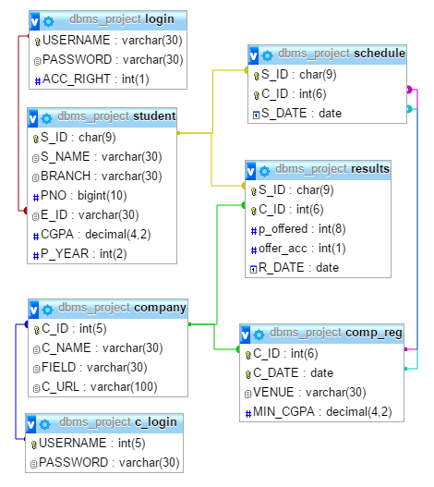

4.2 System Model:-

* Admin Module-

The Placement officer is the administrator of the system. Admin plays a very crucial role in the system. Admin can log in through a username and password. He/she can maintain the placement activities via the system. Admin can add departments, create new batches, add /delete drives. Students can directly join in the placement drive if interested. Admin can manage the training programs conducted in the college. Admin is also able to analyze the placement activities of each student.

* Student Module-

Every student is given a default username and password, using this he/she can enter the system. Students can fill the necessary details like cgpa etc. if interested, students can register for the upcoming drives. The student is also able to attend the online aptitude test being conducted in the system. Based on this aptitude test and other criteria the placement probabilities of a particular student is been predicted.

Data Flow Diagram (DFD)-

A data flow diagram (DFD) is a graphical tool used to describe and analyze the movement of data through a system by depicting the flow of data, source or destination of data and the process that respond to change in data.

The DFD is one of the foremost tools employed by the system analysis to model system components, that are:-

* System Process
* Data Store
* The information flow in the system
* Any external entities that interact with the system.

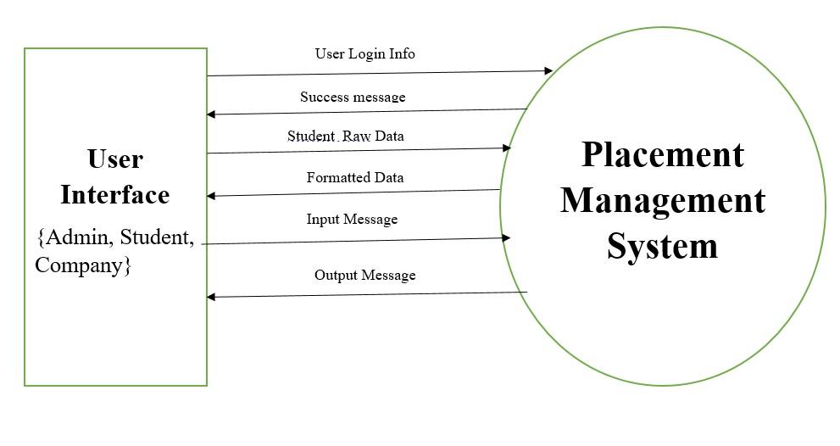

Data Flow Diagram

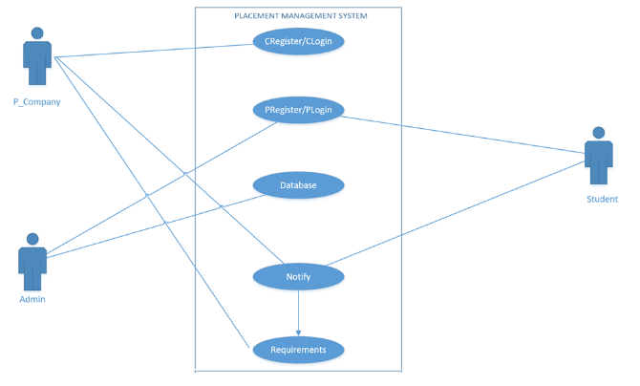

Use Case Diagram

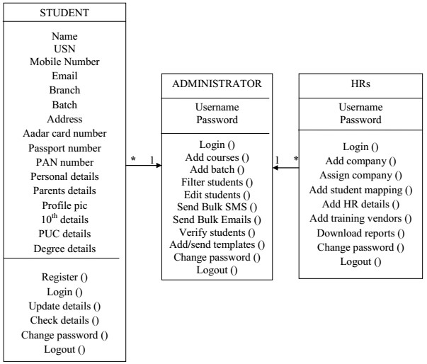

Class Diagram

4.3 Data Model :-

ER Diagram :-

An Entity–relationship model (ER model) describes the structure of a database with the help of a diagram, which is known as Entity Relationship Diagram (ER Diagram). An ER model is a design or blueprint of a database that can later be implemented as a database. The main components of ER model are: entity set and relationship set.

An ER diagram shows the relationship among entity sets. An entity set is a group of similar entities and these entities can have attributes. In terms of DBMS, an entity is a table or attribute of a table in database, so by showing relationship among tables and their attributes, ER diagram showsthe complete logical structure of a database. Let’s have a look at a simple ER diagram to understand this concept .

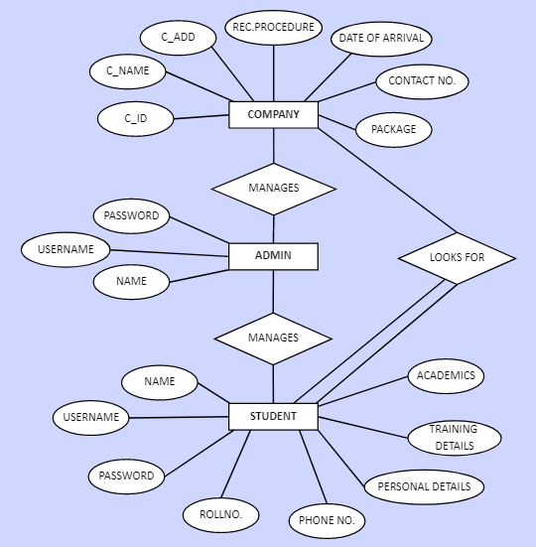

Modules :-

USERS – (Admin, Student)-

* Students can register in companies they are eligible to. i.e. fills schedule table.
* Admin can add/edit list of companies and their details.
* Student details to be filled by students during sign up.
* Username of the student is the email id.
* Email id must have @gmail.com
* Student and administrator can view all result data.
* Admin will fill up results table. Trigger will check presence of schedule if no student is not selected through ppo.
* Trigger on update of result table. If offer accepted made 1 for that student delete all his entries in schedule.
* Date null in results implies PPO.

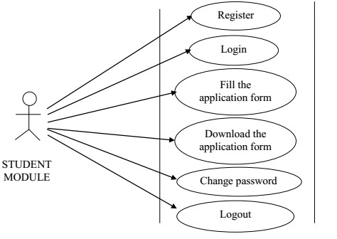

Student Module (Sequence Diagram)

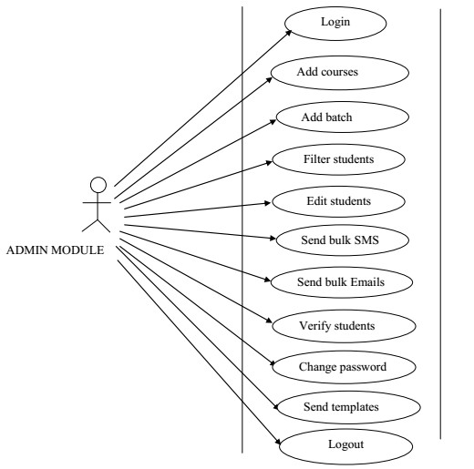

Admin Module (Sequence Diagram)

4.4 User Interface :-

Form 1-

(Login Page)

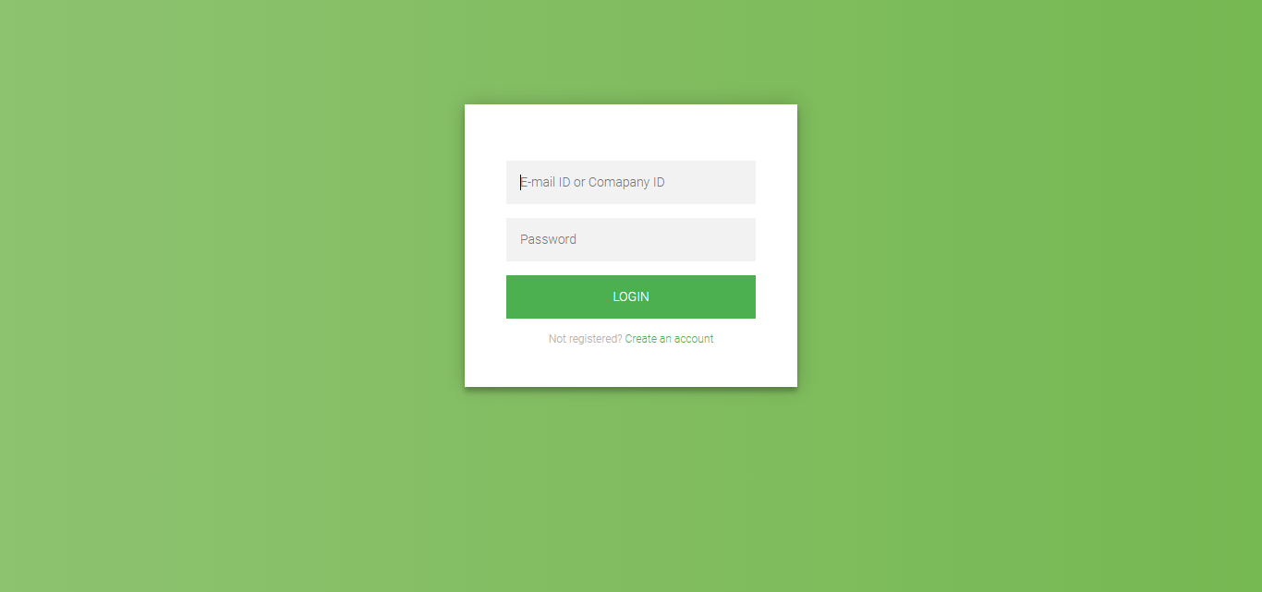

This Form 1 Shows The login or the page when we visit the webpage.

Form 2-

(Sign Up Page)

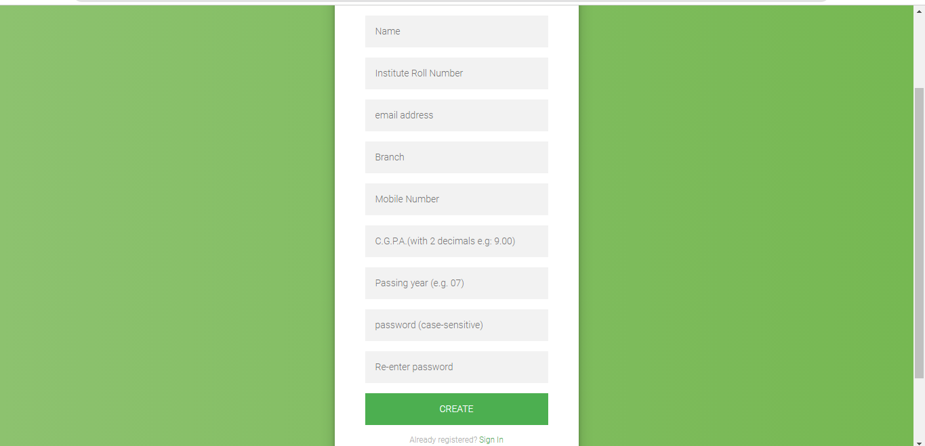

This is Sign Up Page of Student for Student Profile/Login Details.

Form 3-

(Home/Dashboard)

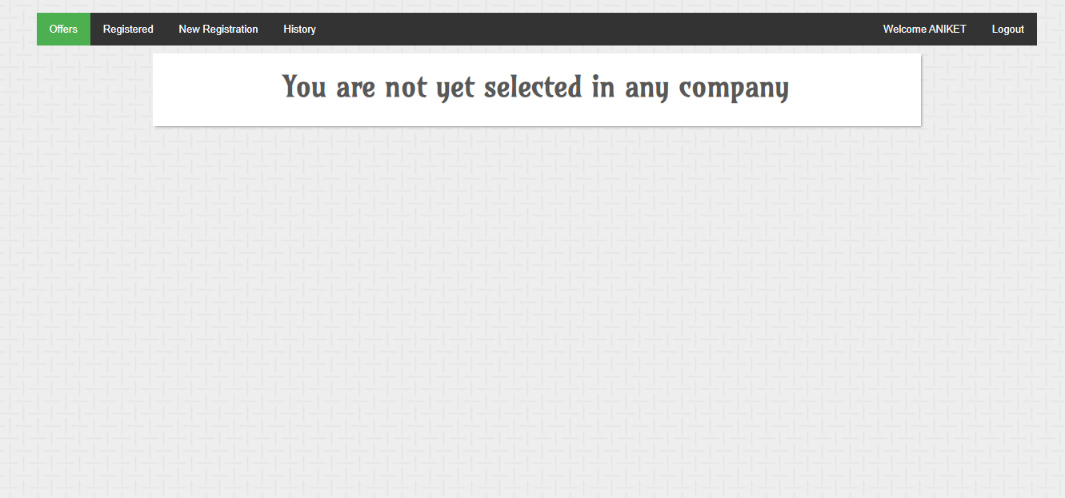

This Page shows the Home page of Logged in Student.

Form 4-

(Admin Page)

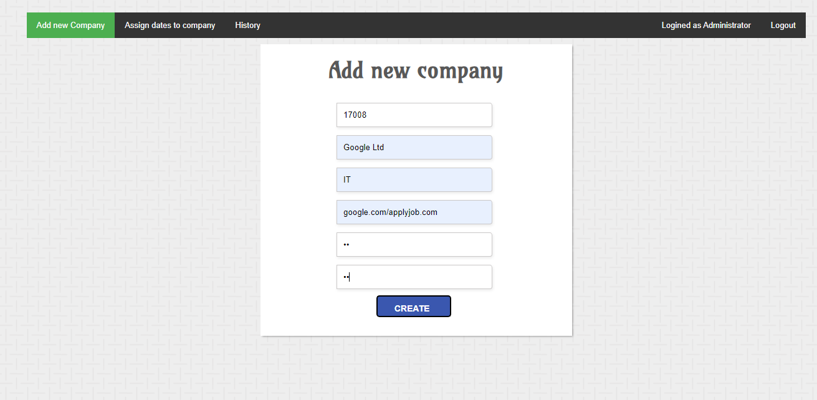

This page shows the Admin control over the Company adding facility.

Form 5-

(Company Page)

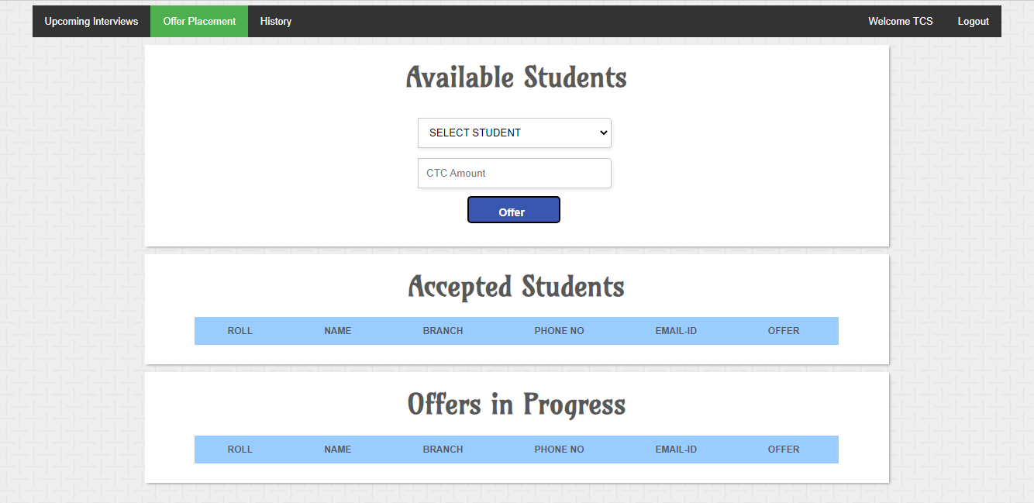

This page shows the shortlisting of students for placement.

Form 6-

(Placement Page)

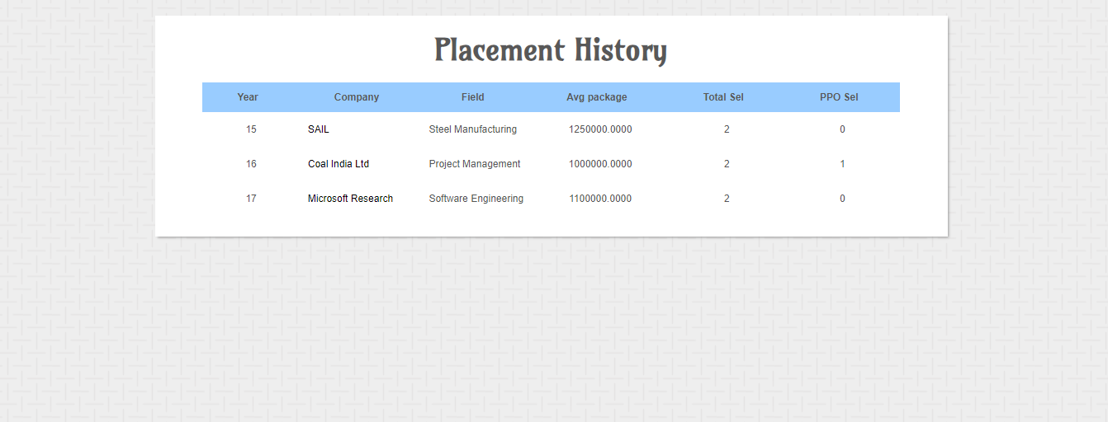

This page shows the Placement history of respective Companies.

5. Implementation Details :-

The term Implementation has different meanings ranging from the conversation of a basic application to a complete replacement of a computer system. The procedures however, are virtually the same. Implementation includes all those activities that take place to convert from old systems to new. The new system may be totally new replacing an existing manual or automated system or it may be major modification to an existing system. The method of implementation and time scale to be adopted is found out initially. Neat the system is test properly and at the same time, the users are trained in the new procedure. Proper implementation is essential to provide a reliable system to meet organization requirement.

5.1 Hardware Requirements –

* Min i3 Processor Based Computer
* Min 4GB-Ram
* Hard Drive Storage
* Monitor

5.1 Software Requirements –

For Users:-

• Internet Connectivity

• Web Browser (Google Chrome, Mozilla Firefox).

For Administrator:-

• Apache Server – to host

• phpmyadmin root access

• MySQL knowledge

• Internet Connectivity

• Web Browser (Google Chrome, Mozilla Firefox).

6. Output and Reports :-

Report –

* It Generates the report on Training, Placement, Users.
* Provide filter reports on Company, Colleges, Registration.
* Application Also Provide data on student info, company registarion,

and placement history.

1. Testing :-

Software testing is a critical element of software quality assurance and represents the ultimate review of specification, designing and coding.

Testing Objectives :-

* Testing is process of executing a program with the intent of finding an error.
* A good test case design is one that has a probability of finding an as yet undiscovered error.
* A successful test is one that uncovers an as yet undiscovered error. These above objectives imply a dramatic change in view port. Testing cannot show the absence of defects, it can only show that software errors are present.

7.1 Data Validation :-

* All the fields such as Training, Company, Registration are validated and does not take invalid values.
* Each form for Training, Placement, Users can not accept blank value fields.
* Avoid errors in Data.
* Controlling amount of input.
* Integration of all the modules/forms in the system.
* Preparation of the test cases.
* Preparation the possible test data with all validation checks.
* Actual testing done manually.
* Recording of the reproduced errors.
* Modifications done for the errors found during testing.
* Prepared the test result scripts after rectification of the errors.
* Functionality of the entire module/forms.
* Validation for user input.
* COMP_REG_CHECK

To make sure company selects dates for interview within the present placement season.

* SC_CHECK
* Check the student registering is eligible for the company based on company criteria (CGPA).
* To ensure a student who has already accepted an offer cannot appear for any more interviews.
* To make sure the final year student registers for the company coming to the college in that particular academic year.
* OFF_ACC_CHECK

To make sure student accepts the offer only during the current placement season.

* OFF_CHECK

To ensure company gives offer to any student only after interview process.

* DEL_YR_CHG

To enable a repeating student to upgrade his passing year by resetting his placement records.

* COMP_ID_CHECK

To ensure the company gets a valid id based on the current academic year.

* RES_ACC_CHECK

To delete all the previous schedules for a student when he accepts any offer.

1. Conclusion :-

Maximum work goes manually in the present placement system which makes it take time to avail changes. This includes main problems like searching for the data of students and sorting them along with it. Also, updating student data is a cumbersome job and does not have a method to notify the student in time which makes the management of the placements very difficult. In the proposed system, all of these problems become automated.

The registration of the student for an upcoming placement, the addition of a new user, notifying students, sharing information, the privacy of the student, etc is all met. The admin validates the information and gives the student list based on the criteria required which otherwise would have been very difficult to manage.

1. Future scope:-

* Multiple round interview can ensured.
* A recommendation system for students which recommends them the companies in which they are most likely to be selected based on previous years statistical data.
* Integrating the placement database with university database to add a whole new range of features.
* More user friendly access through mobile apps and windows applications.
* Direct Messaging between student and company.
* We also create an app which is a app, is used to store information and maintain the placement procedures of a particular area or state in a particular stream.
* We can give more advanced software for placement management system including more facilities.
* We can modify the project with a far better approach with more graphics.

The backup procedure can be comprised to make sure of the database integrity. Also, we can add a page for admin to show total number of students in a particular department and out of t hem how many have been placed. We can also add data of past recruiters along with HR’s contact details and if they have any vacancies.

1. Bibliography and References :-
2. <https://www.w3schools.com/>
3. <https://www.tutorialspoint.com/php>
4. <https://www.mysql.com/>
5. Nirali Publication (PHP)
6. <https://www.tutorialspoint.com/mysql>
7. <https://www.w3schools.com/html/>
8. <https://www.javatpoint.com/xampp>